
TIC TAC TOE

Aun Anis (24P-3017)
Mashaal Khan (24P-3112)

Supervisor:
Sir Saad Rashad

__________________________
Supervisor Signature

Introduction
This project involves the development of a simple yet interactive Tic Tac Toe game using C++ and the SFML (Simple and Fast Multimedia Library). The game will feature a graphical user interface allowing two players to play the classic 3x3 grid game, turn by turn. This project aims to integrate fundamental programming concepts with a graphical interface. The use of SFML ensures a smoother visual presentation and user interaction, moving beyond traditional console-based implementations..

Objectives
- To develop a playable 2-player Tic Tac Toe game.
- To implement a graphical interface using SFML.
- To practice and apply concepts of object-oriented programming.
- To gain experience working with a multimedia/game development library (SFML).
- To understand basic game logic and implement it in an interactive way.

Technologies and Tools Used
- Programming Language: C++
- Library: SFML (Simple and Fast Multimedia Library)
- IDE: Visual Studio Code / Visual Studio
- Operating System: Windows.
- Graphics: SFML (Simple and Fast Multimedia Library)

Features
- Interactive GUI: A clean, intuitive graphical interface created with SFML.
- Two-player mode: Players take turns marking X or O on the grid.
- Win/Tie Detection: The game detects win/tie conditions and displays appropriate messages.
- Restart Option: Players can reset the game to play again without restarting the application.
- Mouse Input Handling: Click-based input for placing Xs and Os.
- Basic Sound Effects (optional): For button clicks or game over screens.

Class Diagram

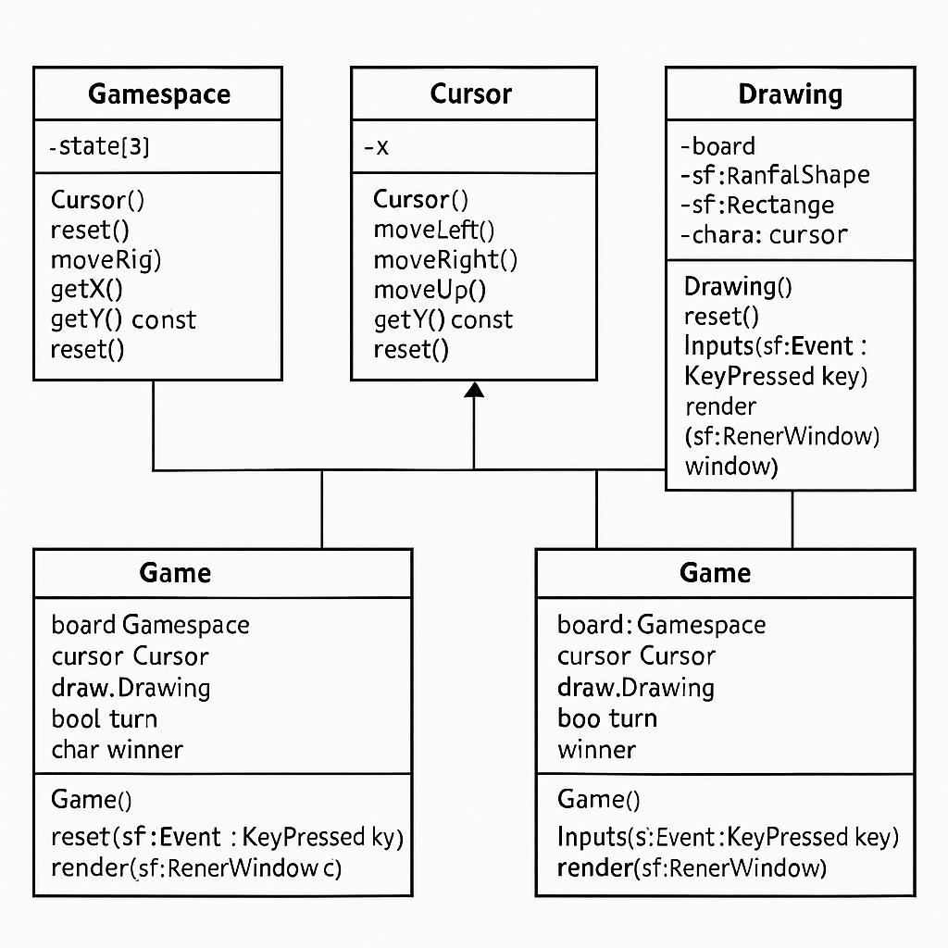
Expected Outcome
A fully functional two player Tic Tac Toe game developed using SFML, featuring smooth gameplay, an engaging user interface, and an enjoyable experience for players.

Conclusion / Importance
This project serves as a foundational step into the world of game development, offering valuable insights into essential mechanics such as input handling, rendering, and game loops. By creating a Tic Tac Toe game using SFML and C++, students can practically apply object-oriented programming concepts in a hands-on and engaging way. It also introduces graphics programming through the use of SFML, which is particularly beneficial for those interested in multimedia applications or game design. Moreover, the project encourages logical thinking and problem-solving by implementing efficient game logic and user interaction. Completing this game not only enhances technical skills but also adds a solid piece to a student’s programming portfolio, demonstrating their ability to build functional and interactive software projects.

